Squaring a Sorted Array (Two-Pointer)
Aim
To read a sorted array of integers (including negative values), square each element, and produce a new array of squared values sorted in non-decreasing order using the two-pointer technique in O(N) time.
Pseudocode
START

Read N
Read array arr[0...N-1]

Create array ans[0...N-1]

left ← 0
right ← N - 1
pos ← N - 1

WHILE left ≤ right DO
IF |arr[left]| > |arr[right]| THEN
ans[pos] ← arr[left] × arr[left]
left ← left + 1
ELSE
ans[pos] ← arr[right] × arr[right]
right ← right - 1
END IF

pos ← pos - 1
END WHILE

FOR i ← 0 TO N - 1 DO
Print ans[i]
END FOR

STOP

Program:
#include <stdio.h>
#include <stdlib.h>

int main() {
int N;
scanf("%d", &N);

int arr[N], ans[N];

for (int i = 0; i < N; i++) {
scanf("%d", &arr[i]);
}

int left = 0, right = N - 1;
int pos = N - 1;

while (left <= right) {
if (abs(arr[left]) > abs(arr[right])) {
ans[pos] = arr[left] * arr[left];
left++;
} else {
ans[pos] = arr[right] * arr[right];
right--;
}
pos--;
}

for (int i = 0; i < N; i++) {
printf("%d ", ans[i]);
}

return 0;
}

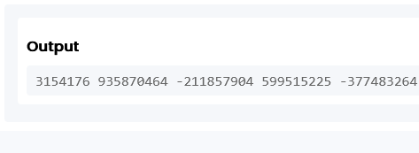

Result:
The program successfully squares each element of the sorted array and returns the squared values in non-decreasing order using the two-pointer technique in O(N) time.

